simple verification for hbase automatic shutdown:

1)open hbase:

HBASE_HOME/bin/start_hbase.sh

2)open hbase shell:

hbase shell

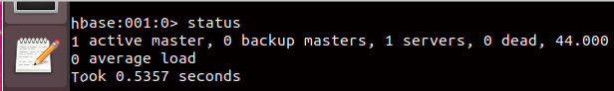hbase> status :  
  
  
  
  
  
  
  
  
3)Debugging :

hdfs fsck /hbase  
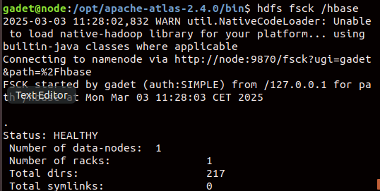  
  
this command will show you if ur hbase has some corrupted files or not  
  
  
hdfs fsck / -files -blocks -locations | grep CORRUPT  
 this command gives you the path of the corrupted file so you can remove  
  
  
hdfs dfs -rm /path/to/corrupted/file  
removing the files ….  
  
after that,restart hbase